A000-Asia-Persia-Amlash-Deer-Rhyton-800 BCE

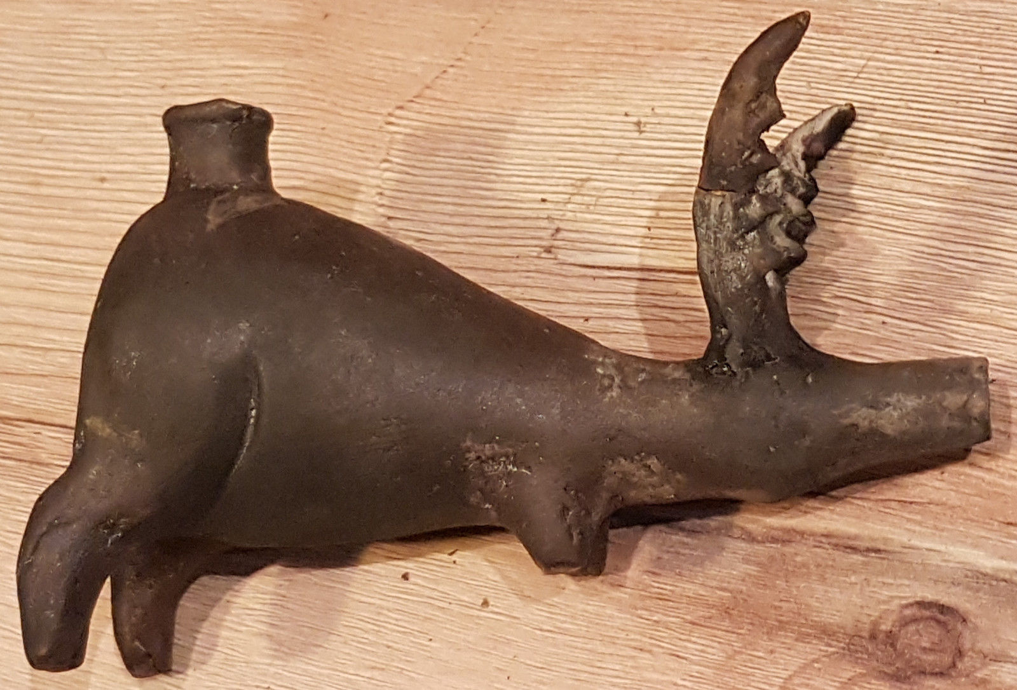

Persian Terracotta Sculpture of a Deer, Amlash Style, Iran

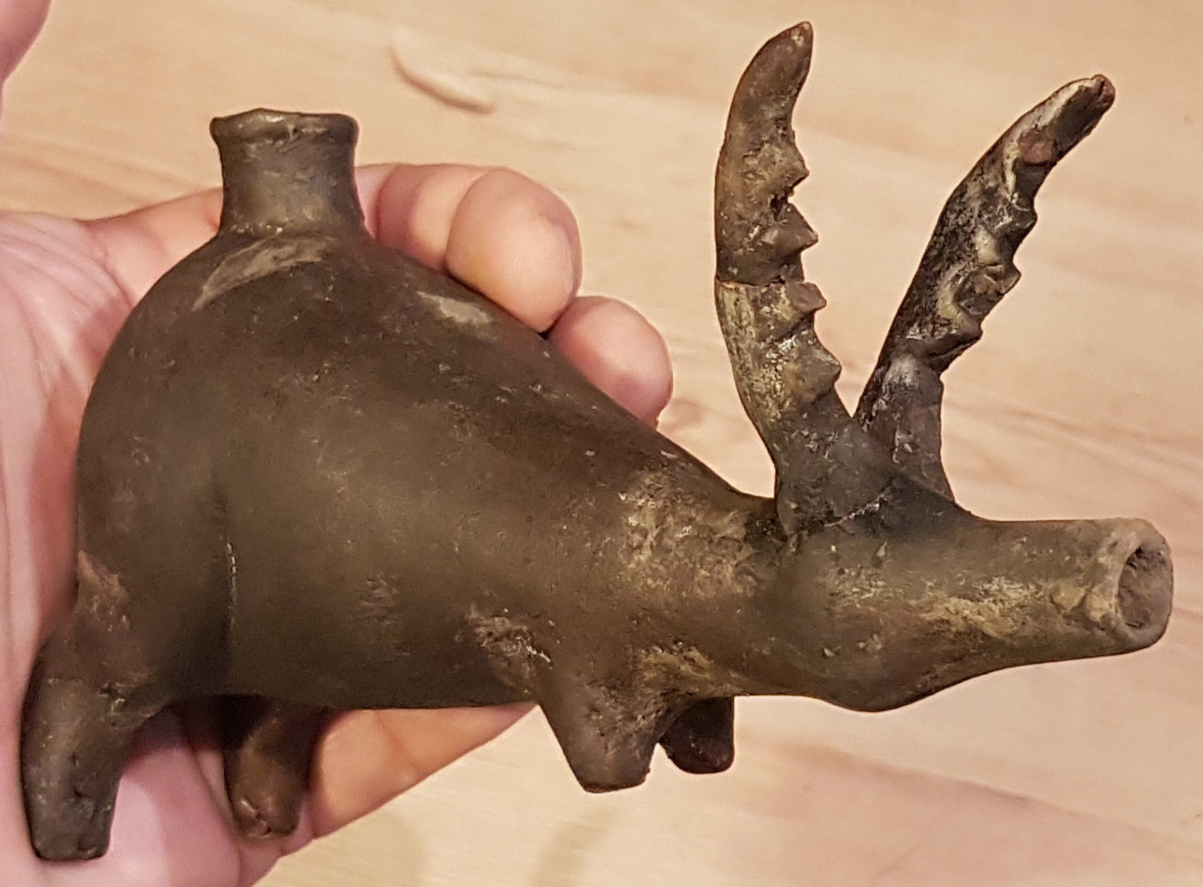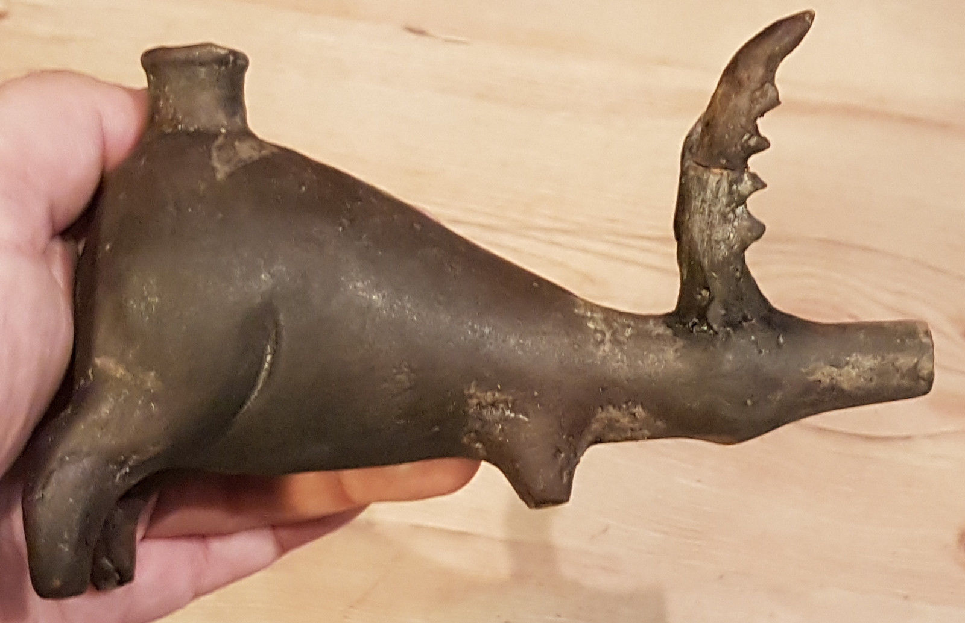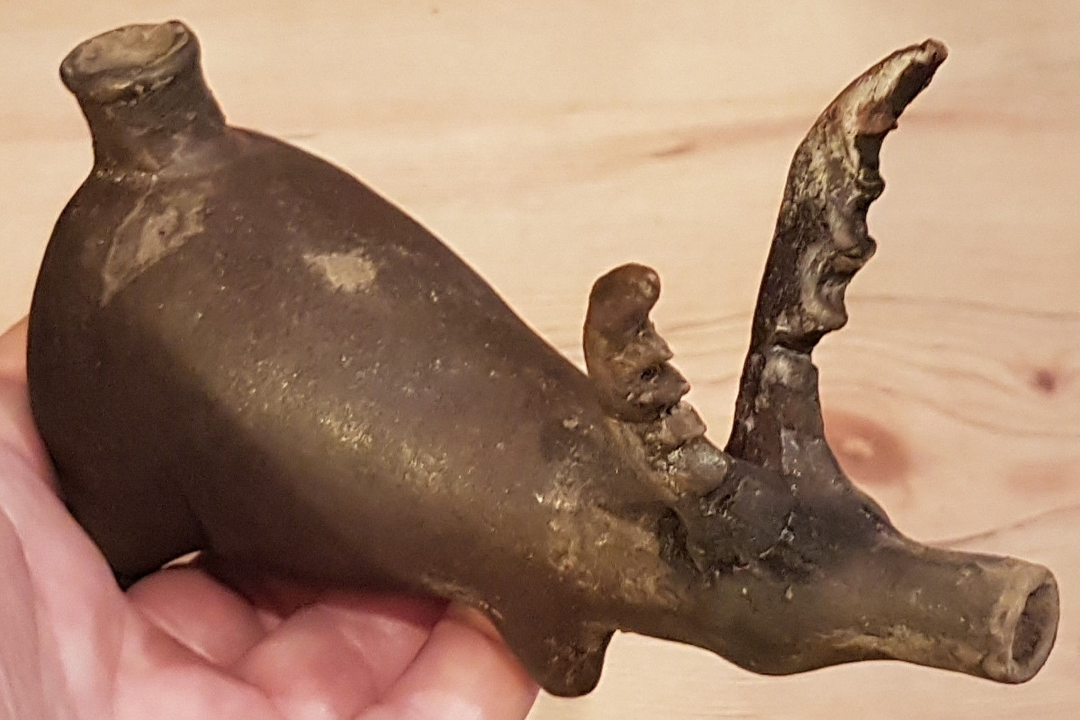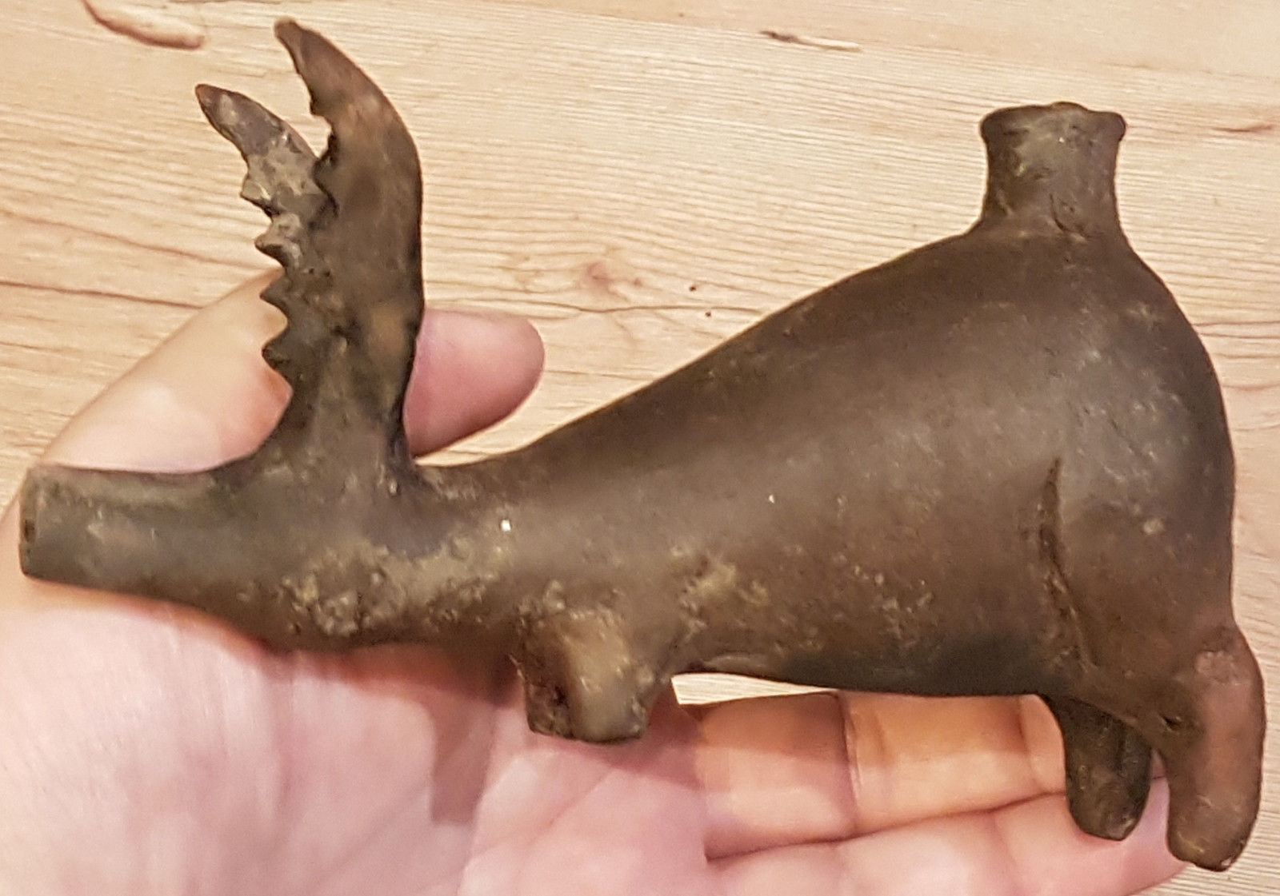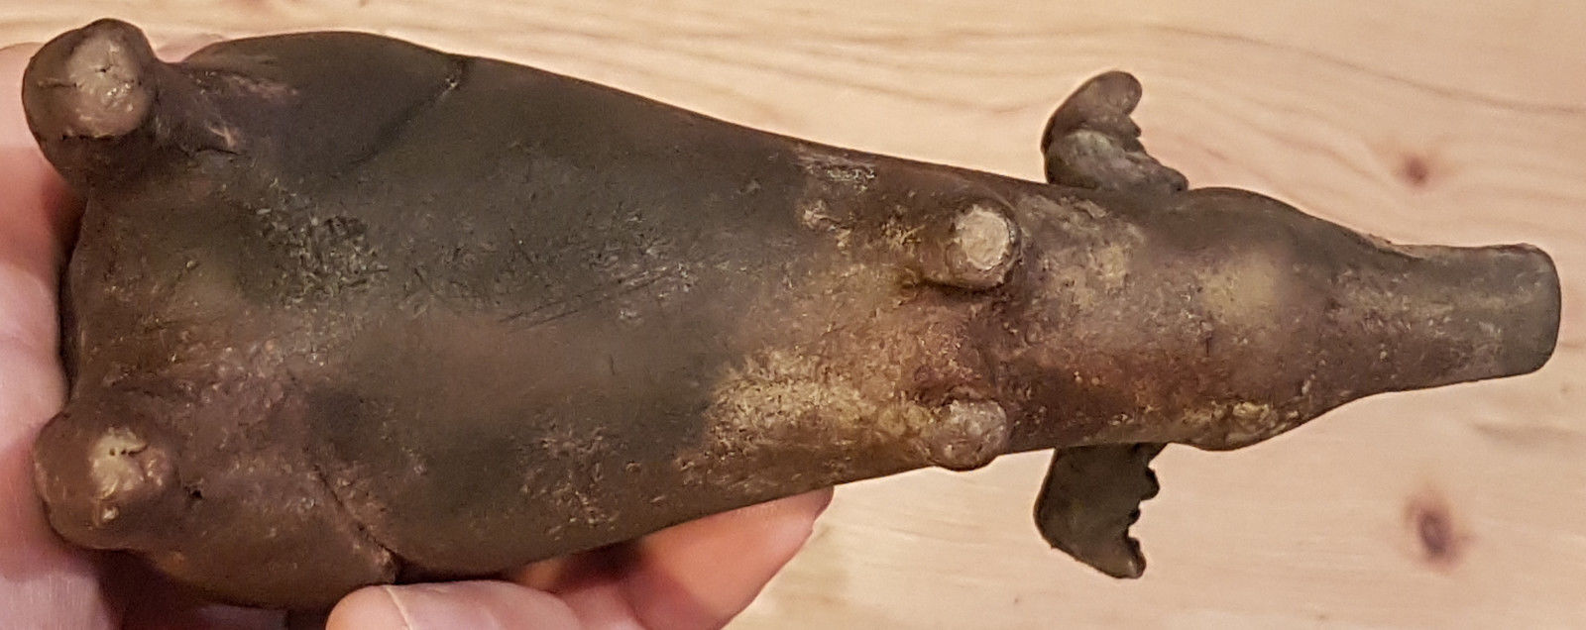

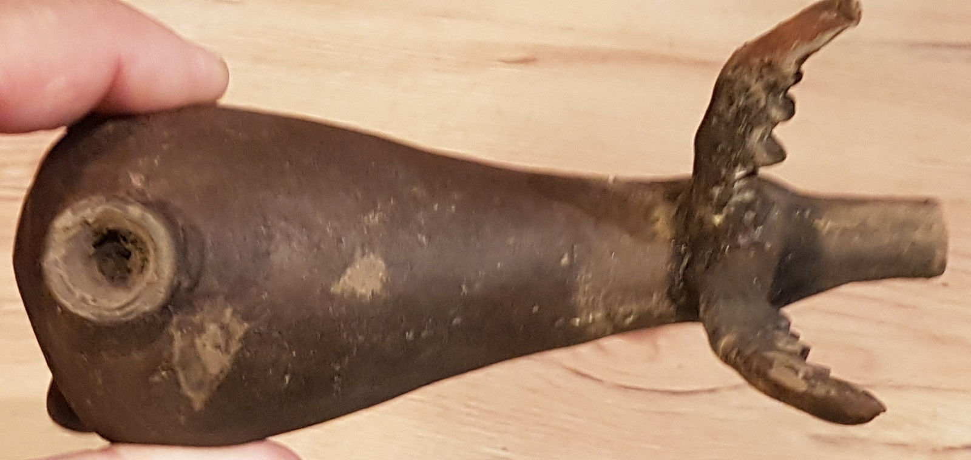

A000-Asia-Persia-Amlash-Deer-Rhyton

**Case no.: 4**

**Accession Number:**

**Formal Label:** A000-Asia-Persia-Amlash-Deer-Rhyton

**Display Description:**

**An Amlash terracotta stag rhyton**  
**Early 1st Millennium BCE**  
The hollow vessel with flaring filler hole rising from its back, the high arching antlers with pointed detail, with a cylindrical spouted muzzle, *10½in (26.8cm) long*

### FOOTNOTES

* *Provenance*:  
  From an old European collection.   
  **lampsack_gallery**.

**LC Classification:**

**Date or Time Horizon:**

**Geographical Area:**

**Map:**

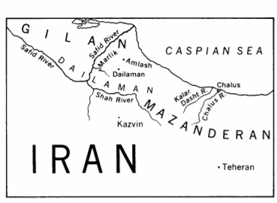

**GPS coordinates:**

**Cultural Affiliation:**

**Media:** **Dimensions:**

**Weight:**

**Condition:**

**Provenance:**

**Discussion:**

**Amlash culture** refers to an assortment of historic materials and periods in [Gilan](https://en.wikipedia.org/wiki/Gilan" \o "Gilan) and west of [Mazandaran](https://en.wikipedia.org/wiki/Mazandaran), in north of [Iran](https://en.wikipedia.org/wiki/Iran). Amlash refers to the geographical region from which some archeological objects of certain types come It does not have any real archeological meaning when used with the word culture. These objects which are attributed to Amlaš have been shown in many exhibitions in Europe and the United States and may often be seen in catalogues.

[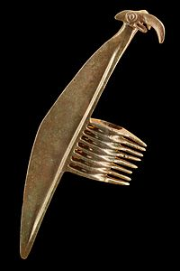](https://en.wikipedia.org/wiki/File:Halberd-axe_MBA_Lyon_E_697a-IMG_0110-0111.jpg)

بندانگشتی

[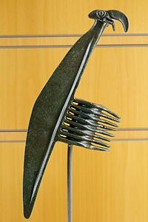](https://en.wikipedia.org/wiki/File:Halberd-axe_Luristan_MBA_Lyon_InvE697-a.jpg)

[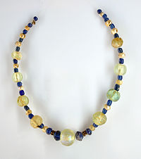](https://en.wikipedia.org/wiki/File:MRAH_Verre_02_Collier_Iran.jpg)

[Amlash](https://en.wikipedia.org/wiki/Amlash_County), now a county in [Gilan province](https://en.wikipedia.org/wiki/Gilan_province" \o "Gilan province), was a small village in southeastern Gilan in 1959. The name originates from the nearby [Alborz](https://en.wikipedia.org/wiki/Alborz) valleys where archaeological artifacts were discovered during excavations. The artifacts range in date from the late second millennium BC through the [Partho-Sasanian](https://en.wikipedia.org/w/index.php?title=Partho-Sasanian&action=edit&redlink=1" \o "Partho-Sasanian (page does not exist)) period, but most of the objects are dated to the 9th-8th centuries BC. Dating and meaning of the known objects (bronze weapons and animal figurines, human statuettes of terra cotta and bronze, pottery animal effigy vases, and burnished black, gray, or orange pottery vessels) is complicated by insufficient archaeological contexts.

["AMLAŠ ii. Excavations"](http://www.iranicaonline.org/articles/amlas-excavations). [*www.iranicaonline.org*](http://www.iranicaonline.org)

The designation "Amlash" has been used quite loosely as the place of origin for many antiquities that have come from other, sometimes unknown, sites in the province of Gilan, which extends southward from the southwest shore of the Caspian Sea. Here, in the area of the Safid River and its tributaries, a region long known as Dailaman, lie the archaeological sites of Amlash, Marlik, and Dailaman, among others. It has been possible, however, to trace relationships between objects found in the Dailaman region and others found elsewhere, especially in the Kalar Dasht River region, in the province of Mazanderan, somewhat under a hundred miles to the east. Important discoveries were made there, near Chalus, when excavations were dug for a palace for the late Shah Riza Pahlavi. In two respects Marlik, on the Gohar River (a tributary of the Safid), has proved the most important of all these rich sites. In the first place, Marlik was dug in I96 - I962 by E. O. Negahban, on behalf of the University of Teheran and the Archaeological Service of Iran, in such a fashion that notes, photographs, and drawings were made of the objects in situ. In the second place, Dr. Negahban succeeded in finding a series of intact graves of warriors, of warrior-kings and their wives, and even of their horses. As a result of his work it is known that certain types of earthenware figures were found in graves together with specific kinds of weapons, jewelry, and other objects of bronze, silver, and gold. So disparate in style are these objects that, had they been known only through their appearance in the antiquities market, not even an archaeologist would have believed that certain of them could have come from one place. But for Negahban's discoveries, the problems in understanding the flood of material that has been obtained by all sorts of means from the Safid River region would be even greater than they are now.

In the catalogue for the American showing of the 7000 Years of Iranian Art, Edith Porada called the culture that produced the material found in these tombs the Marlik culture. This use of the name of a very small place to denote an entire archaeological culture has its precedent in Mesopotamian archaeology (e.g., al-'Ubaid and Jamdat Nasr), and will be employed here. Who the Marlik people were is unknown. They seem to have flourished from near the end of the second millennium B.C. to the beginning of the first - after the Kassite empire in the south of Mesopotamia had come to a close, and contemporaneously with the last Middle Assyrian kings. No written records of the Marlik culture exist, nor are there any others concerning the area at this particular period. Later, in the ninth century B.C., Assyrian records that speak of Mannaeans and Medes in northwest Iran may be dealing with the end of this culture. Among the examples of the Marlik culture that are to be seen in the Museum, as a result of recent gifts, loans, and purchases, is an earthenware bull (Figure i) of the same type as those found by Negahban. Similar bulls have also been found elsewhere, namely at Garmabak, near the Chalus Road, which runs north from Teheran to the Caspian. A Mazanderan bull was published (in Persian) by H. Samadi of the Archaeological Service of Iran in I956, several years before Negahban's finds. Dozens of similar animals have since appeared, and are now in collections all over the world. Comparison of the pottery bulls with actual humped bulls of Iran (Figure 2) makes clear that the hump is exaggerated, often to an extraordinary degree. This emphasis was doubtless made to convey the impression of enormous power-not surprising when one considers how important bulls were in the ancient economies. Common to most is the spoutlike mouth, which probably served some practical purpose. Also usual are the much shortened legs. These perhaps assure the stability of the piece, or perhaps they were simply less trouble for the potter to make. Some of the pottery bulls have additions such as metal earrings.

1. 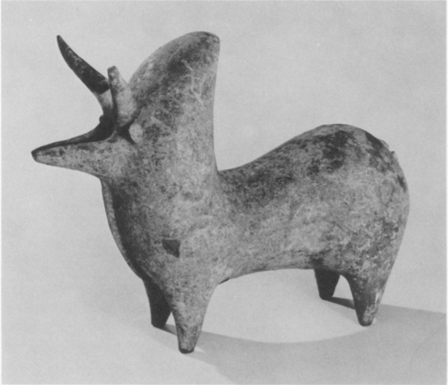
2. 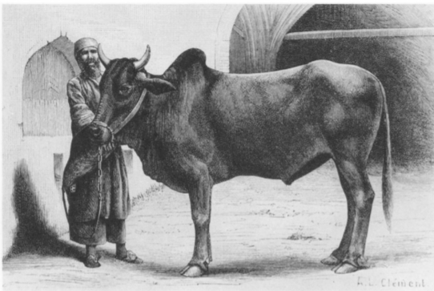
3. Bull, from the Safid River region. Late I - early I millennium B.C. Earthenware, height 7 inches. Lent anonymously, L62.15.2 2. Iranian humped bull. Woodcutfrom La Perse, la Chaldee, et la Susiane, by Jane Dieulafoy (Paris, i887). The Library of the Metropolitan Museum

The exaggerations of the earthenware figures do not appear in the gold vessels found at Marlik. On those decorated with bulls the emphasis is on locks of hair growing from the chests, backs, and leg joints. Neither the body shape nor the hair, however, is exaggerated on the four gazelles that walk in procession around a gold cup from the Safid River region (Frontispiece). Nothing in Iranian antiquities could offer a greater contrast in feeling and style than this cup and the bull of Figure i, but the contrast cannot be accounted for entirely by the differences in the mediums and the subjects. In the gazelles there is a grace and delicacy that suggest a court style, whereas the bulls on the Marlik gold vessels show a provincial version of a foreign sophistication. The bodies of the gazelles are repousse and chased, the hair indicated by means of short strokes and dots contained within outlined conventional shapes that do not conform to nature. The heads, projecting in the full round, look at first as though they must have been hammered out from the body of the cup. Instead, they were hammered up separately and then fastened invisibly in place by a method much practiced in Iran in antiquity: colloid hard-soldering, a process involving a copper salt and glue. The ears, which almost quiver with life in the sensitively modeled heads, were also made separately. So, too, were the horns, each of which is composed of a strip of thin gold rolled up tightly and shaped appropriately. Originally the horns just cleared, in a most elegant manner, the cup's everted rim; some of them have now been crushed down upon it. The hoofs are indented, doubtless for the insertion of inlays such as once filled the recessed eyes. No trace of these inlays has survived -a loss that gives the cup a homogeneity it once did not possess. The decoration includes two guilloche borders, a double one at the top, a single one below. The sides of the cup swell as they approach the base, so that the cup appears to rest on an inflated ring. The base itself (Figure 3) is decorated with a pattern of six-petaled rosettes formed by overlapping circles contained within a narrow circular band hatched like a cord. The background of this design is nicked with small dots. The technique used in making the gazelles' horns is to be seen on other metal objects from the Safid River region. One of these is a pair of gold earrings with hollow animal bodies decorated with small granular rosettes (Figure 4). The heads that project at one end are very like the heads on the gazelle cup, even to the socketed eyes, and the horns were made in precisely the same way. Earrings closely related to this pair were found at Marlik by Negahban. They are simpler in that they do not have animal heads, but they have the same bulbous form and they are adorned with the same kind of granular rosette. Another of these technically related objects from Marlik is a gold beaker decorated with winged bulls whose heads project in the full round, with horns made in the manner described above

REFERENCES For Marlik earrings: E. 0. Negahban, "A Brief Report on Marlik in Iran" in Journal of British Institute of Persian Studies, II (1964), pp. 13-19. For Susa cup: G. Contenau, Manuel d'archeologie orientale, depuis les origines jusqu'a l'epoque d'Alexandre, II (I93I), 632. For Elamite helmets: R. D. Barnett, Assyrian Palace Reliefs and Their Influence on the Sculpture of Babylonia and Persia (1960), P1. 121.

From C H A R L E S K. W IL K I N S O N, Art of the Marlik Culture, MMA, NYC

**References:**

APPENDIX:

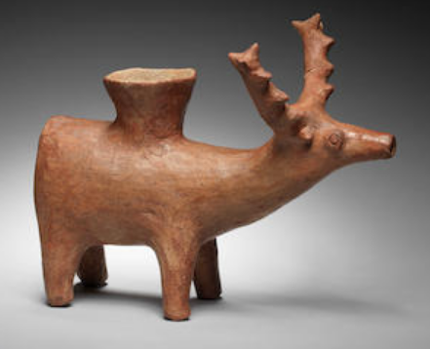

[Bonhams](https://www.bonhams.com/)

Lot 154

**AN AMLASH TERRACOTTA STAG RHYTON**

**£ 2,000 - 2,500  
US$ 2,600 - 3,200**

**[ANTIQUITIES](https://www.bonhams.com/auctions/19961/)**

25 Apr 2012, 11:00 BST

[LONDON, NEW BOND STREET](https://www.bonhams.com/locations/BS/)

**An Amlash terracotta stag rhyton**  
**Early 1st Millennium B.C.**  
The hollow vessel with flaring filler hole rising from its back, the high arching antlers with pointed detail, with a cylindrical spouted muzzle, *10½in (26.8cm) long*

### FOOTNOTES

* *Provenance*:  
  European art market prior to 1975.

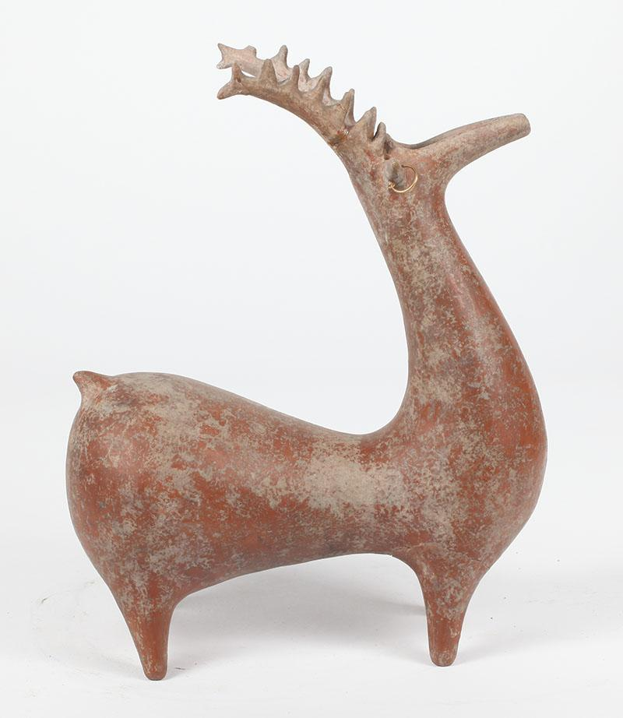



**Estimate**  
$1200-1800

**Provenance**

**Measurements**  
Height: 13 inches

**Weight**  
Approximately 2 3/4 lb.

**Condition**  
The deer with approximately 3 glued repairs to the right antler, one at the base, one at the tip, and one to a projected detail; the left antler with a break near the tip; each front leg broken and repaired near the join to the body, the lines of the breaks chipped; restoration to the upper neck